1. Design DFA using simulator to accept even number of a’s.

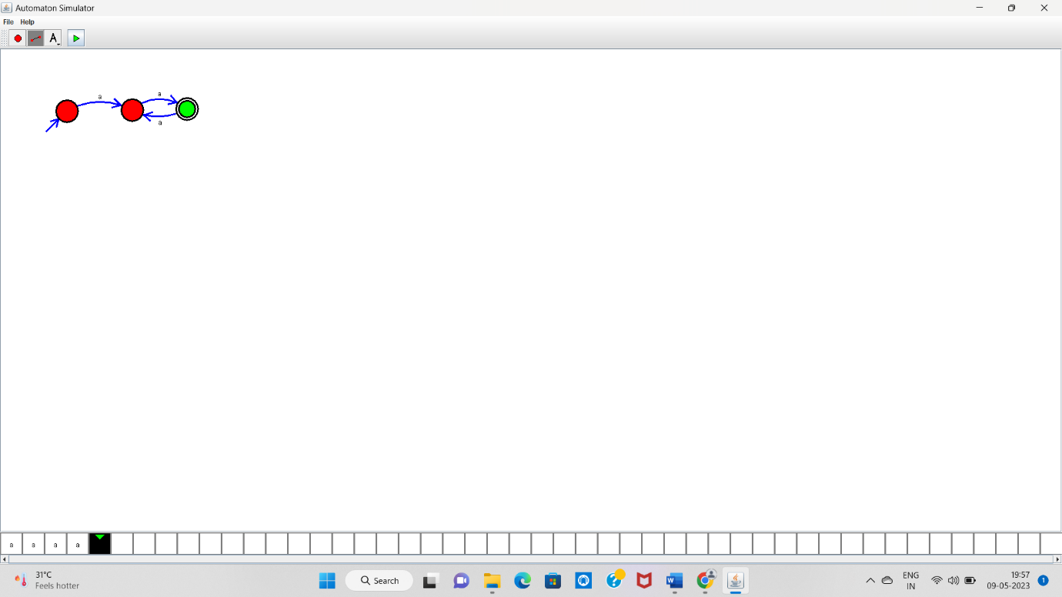

aaaa ---- Accepted